Lab # 06



Fall 2024

**CSE-310L Control Systems Lab**

Submitted by: MUHAMMAD SADEEQ

Registration No.: 21PWCSE2028

Section: C

“On my honor, as a student of the University of Engineering and Technology, I have neither given nor received unauthorized assistance on this academic work”

Submitted to:

Dr. Muniba Ashfaq

(1 Dec 2024)

Department of Computer systems engineering

University of Engineering and Technology, Peshawar

**Objectives:**

The objective of this lab is to learn about:

* finding the Laplace and Inverse Laplace transforms using MATLAB

**5.1 Use the MATLAB and Control System Toolbox to form a linear time invariant system transfer function**

$$F\left(s\right)= \frac{2}{\left(s+1\right){(s+2)}^{2}}$$

**Code:**

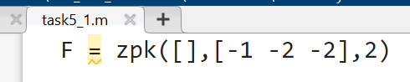

**Output:**

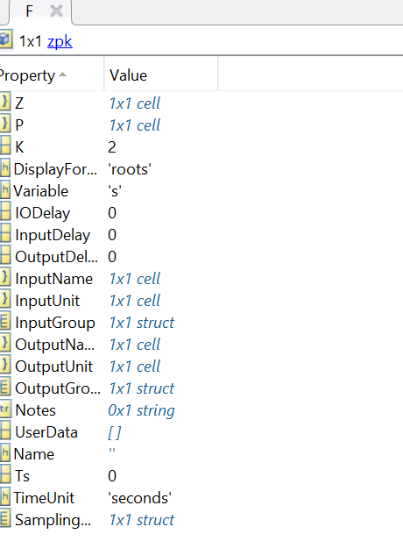

5.2 Use the MATLAB to get the equation

$$f\left(t\right)=2e^{-t}-2{te}^{-2t}-2e^{-2t}$$

**Task 8:**

**Code:**

**Output:**

5.3 Use the MATLAB and Control System Toolbox to form a linear time invariant system transfer function

$$F\left(s\right)= \frac{3}{s(s^{2}+2s+5)}$$

**Code:**

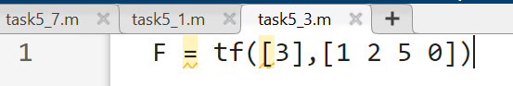

**Output:**

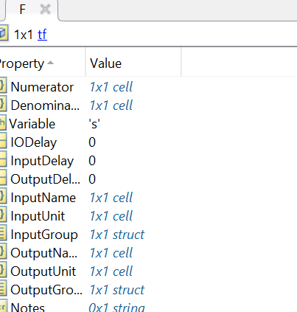

5.4 Use the MATLAB to find the inverse laplace transform of the system transfer function

$$F\left(s\right)= \frac{3}{s(s^{2}+2s+5)}$$

**Code:**

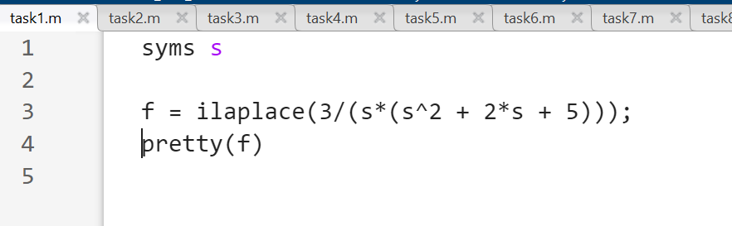

**Output:**

5.5 Use MATLAB to get the following equation

$$F\left(s\right)=\frac{3/5}{s}-\frac{3}{20}\left(\frac{2+j1}{s+1+j2}+\frac{2-j1}{s+1-j2}\right)$$

**Code:**

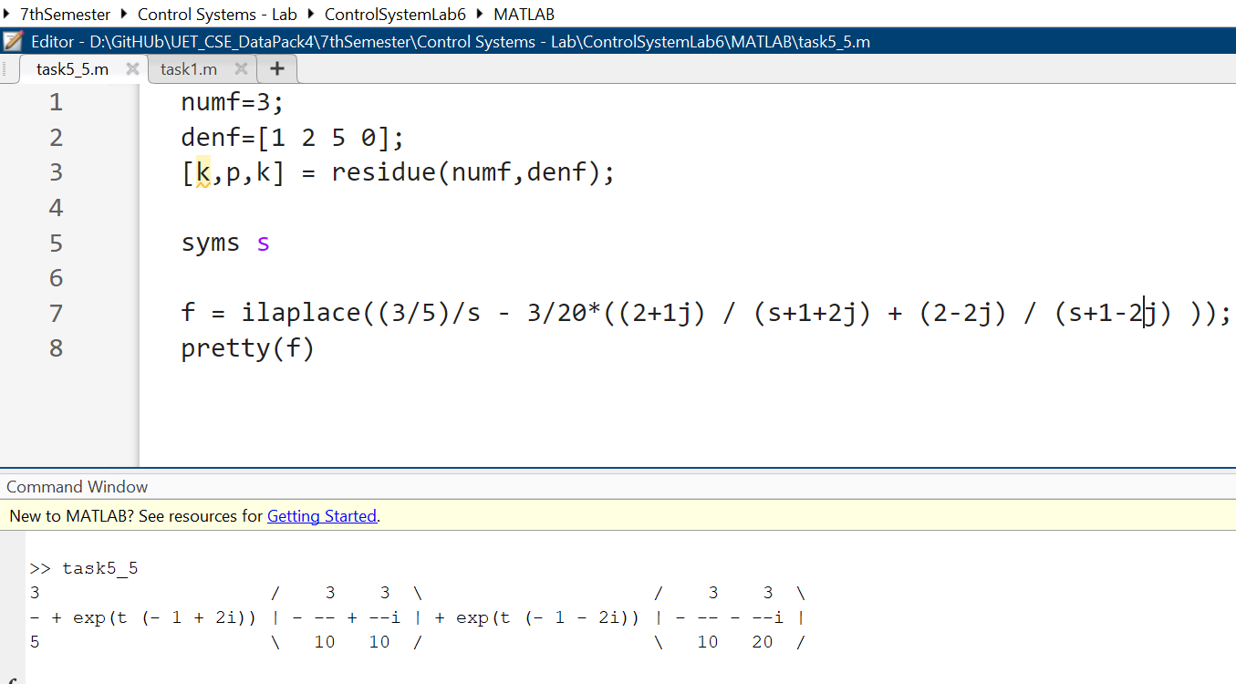

**Output:**

5.6 Use the MATLAB to find the inverse laplace transform of the system transfer function

**Code:**

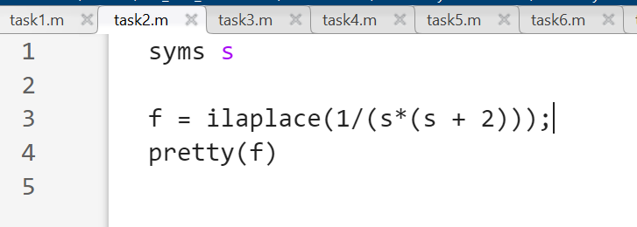

**Output:**

5.7 Use MATLAB to plot the following function for t from 0 to 1 with the intervals of 0.01

**Code:**

**Output:**

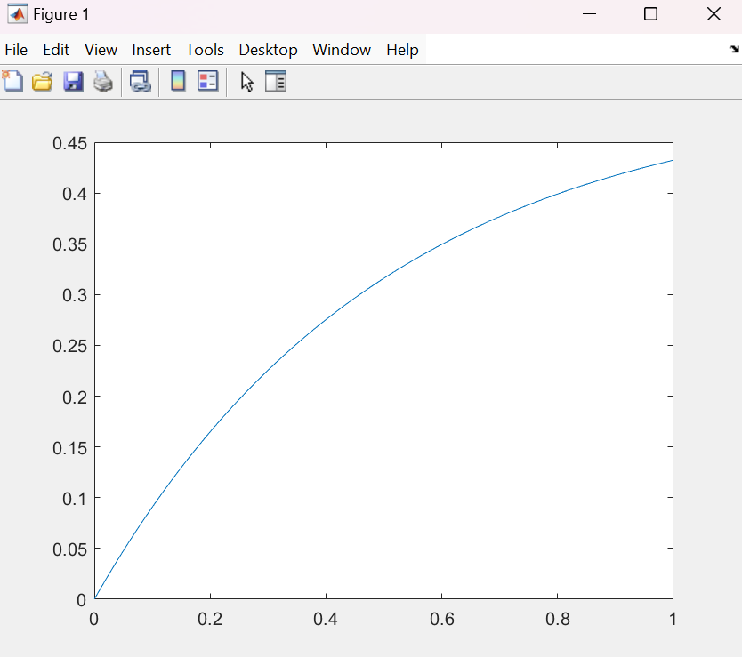

5.8 Use MATLAB and Symbolic Math Toolbox to help you solve the following equation for currents.

**Code:**

**Output:**

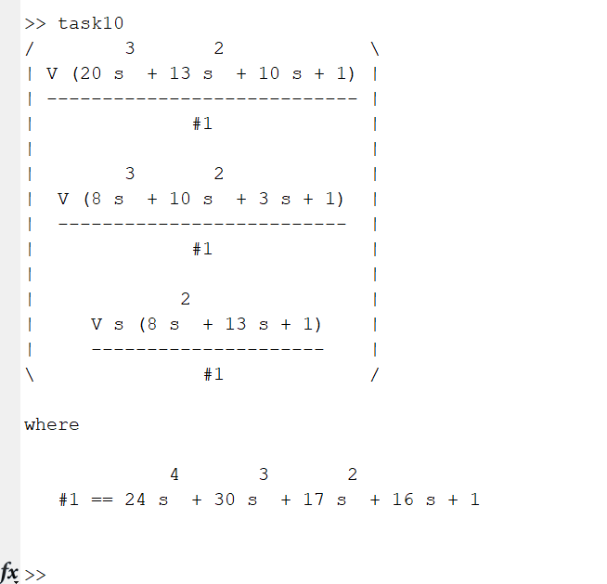

**Lab Tasks:**

**Task 1:**

**Code:**

**Output:**

**Task 2:**

**Code:**

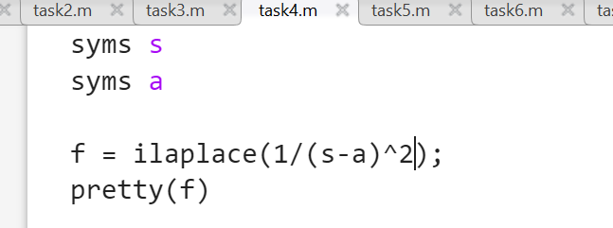

**Output:**

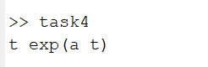

**Task 3:**

**Code:**

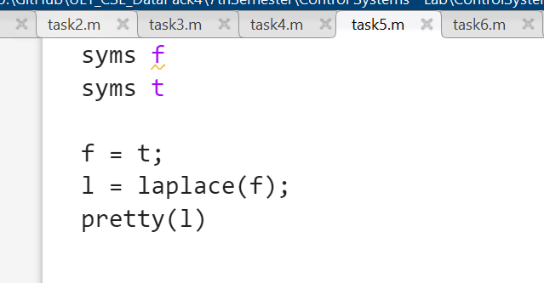

**Output:**

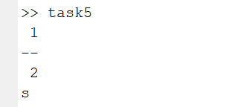

**Task 4:**

**Code:**

**Output:**

**Task 5:**

**Code:**

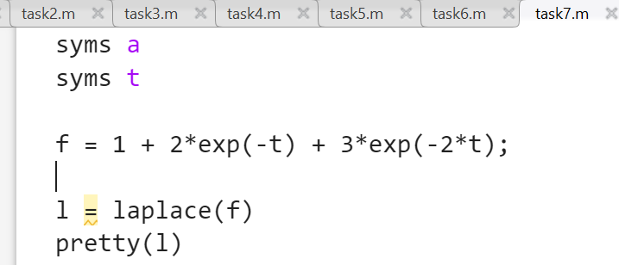

**Output:**

**Task 6:**

**Code:**

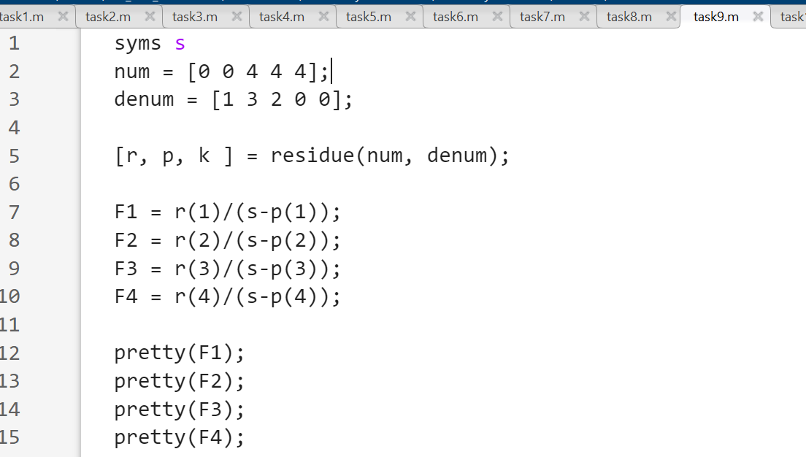

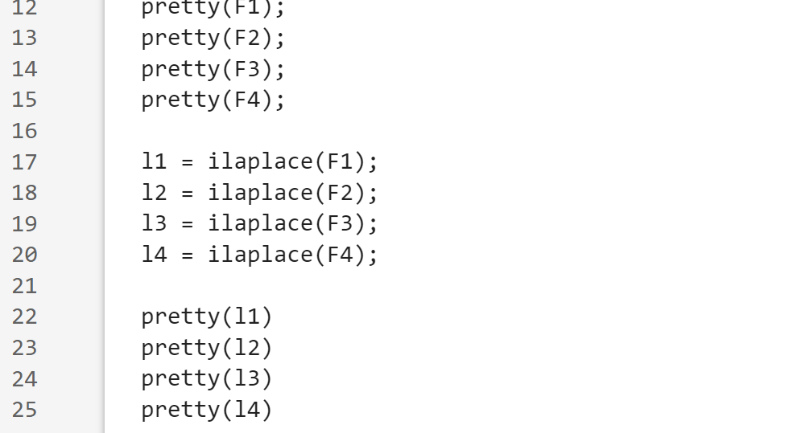**Output:**

